* create DATABASE award_winner
* CREATE TABLE NobelWinners (

Year INT,

Subject VARCHAR(50),

Winner VARCHAR(100),

Country VARCHAR(50),

Category VARCHAR(50)

);

* INSERT INTO NobelWinners (Year, Subject, Winner, Country, Category) VALUES

(1970, 'Physics', 'Hannes Alfven', 'Sweden', 'Scientist'),

(1970, 'Physics', 'Louis Neel', 'France', 'Scientist'),

(1970, 'Chemistry', 'Luis Federico Leloir', 'France', 'Scientist'),

(1970, 'Physiology', 'Ulf von Euler', 'Sweden', 'Scientist'),

(1970, 'Physiology', 'Bernard Katz', 'Germany', 'Scientist'),

(1970, 'Literature', 'Aleksandr Solzhenitsyn', 'Russia', 'Linguist'),

(1970, 'Economics', 'Paul Samuelson', 'USA', 'Economist'),

(1971, 'Physiology', 'Julius Axelrod', 'USA', 'Scientist'),

(1971, 'Physics', 'Dennis Gabor', 'Hungary', 'Scientist'),

(1971, 'Chemistry', 'Gerhard Herzberg', 'Germany', 'Scientist'),

(1971, 'Peace', 'Willy Brandt', 'Germany', 'Chancellor'),

(1971, 'Literature', 'Pablo Neruda', 'Chile', 'Linguist'),

(1971, 'Economics', 'Simon Kuznets', 'Russia', 'Economist'),

(1978, 'Peace', 'Anwar al-Sadat', 'Egypt', 'President'),

(1978, 'Peace', 'Menachem Begin', 'Israel', 'Prime Minister'),

(1987, 'Chemistry', 'Donald J. Cram', 'USA', 'Scientist'),

(1987, 'Chemistry', 'Jean-Marie Lehn', 'France', 'Scientist'),

(1987, 'Physiology', 'Susumu Tonegawa', 'Japan', 'Scientist'),

(1984, 'Economics', 'Reinhard Selten', 'Germany', 'Economist'),

(1994, 'Peace', 'Yitzhak Rabin', 'Israel', 'Prime Minister'),

(1987, 'Physics', 'Johannes Georg Bednorz', 'Germany', 'Scientist'),

(1987, 'Literature', 'Joseph Brodsky', 'Russia', 'Linguist'),

(1987, 'Economics', 'Robert Solow', 'USA', 'Economist'),

(1994, 'Literature', 'Kenzaburo Oe', 'Japan', 'Linguist');

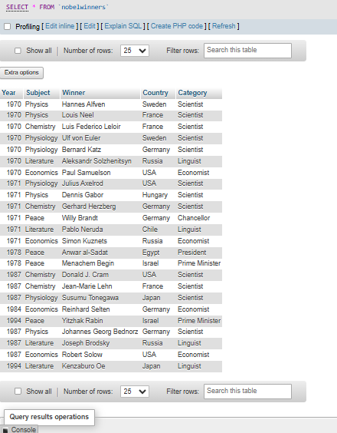

**Now make sure to solve the following query :**

● Write sql query to find the nobel prize winners of the year 1970. Return year,subject and winner

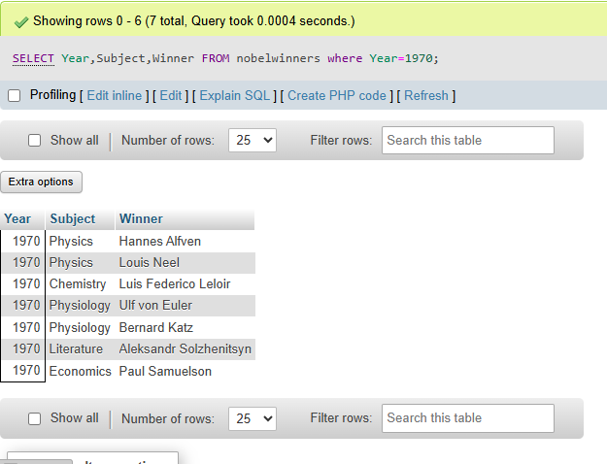

● Write sql query to find the nobel prize winners in chemistry between the years 1965 and 1975. Begin and end values are included Return year, subject, winner and country.

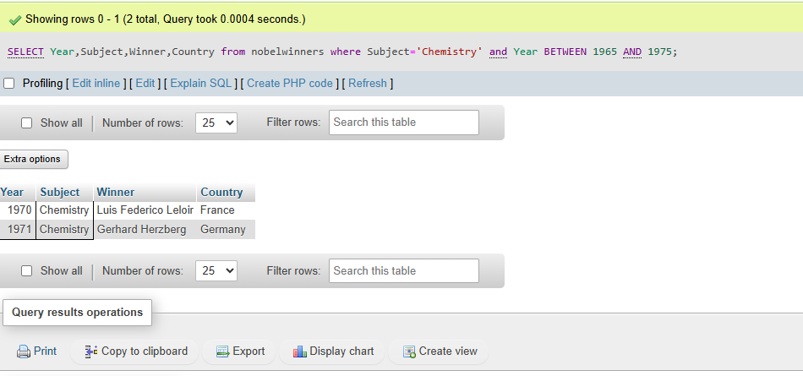

● Write sql query to retrieve the details of the winners whose first name matches with the string ‘Louis’. Return year,subject,winner,country.

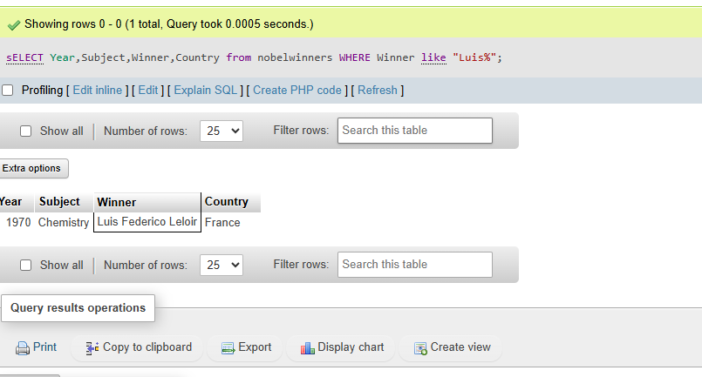

● Write sql query to find Nobel prize winners for the subject that does not begin with the letter ‘P’. Order the result by year, descending and winner in ascending.

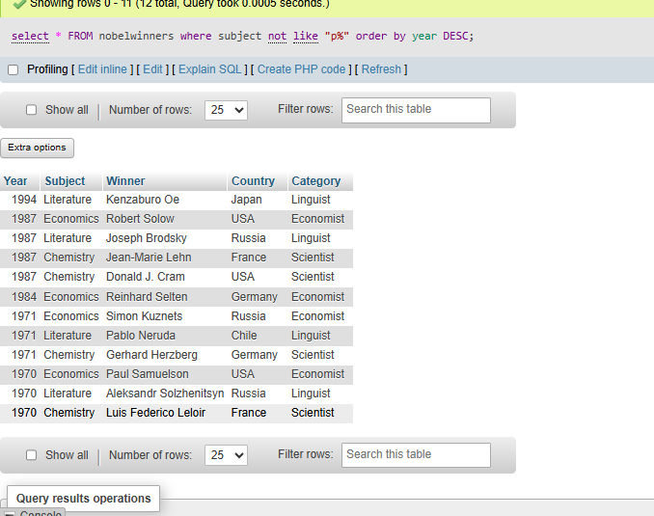

● Write sql query to find the details of 1970 Nobel prize winners. Order the result by subject, ascending except for ‘Chemistry’ and ‘Economics’ which will come at the end of the result set. Return year, subject, winner , country and category. Make sure to make your clean and clear code. 